Name:
Date:
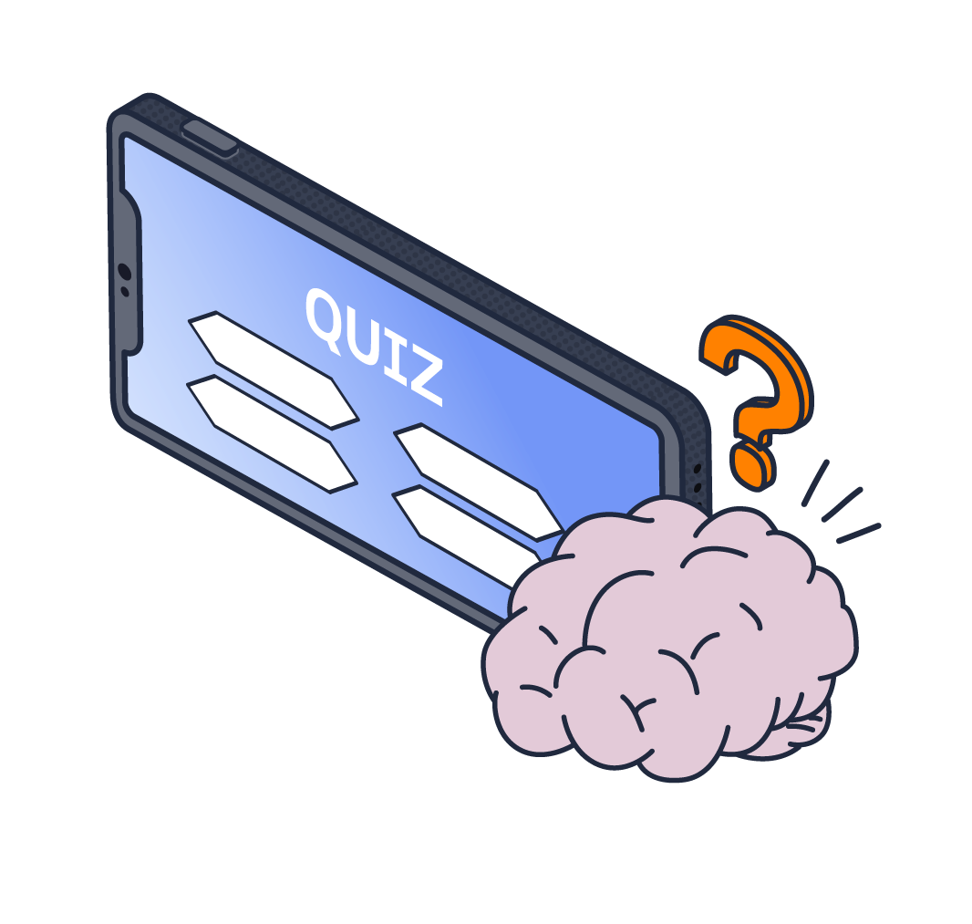
KCSIE 2026 quiz

- Have you read and understood Part One of KCSIE?

☐ Yes
☐ No

- According to KCSIE, up to what age is an individual considered a child?

☐ 13 years old
☐ 16 years old
☐ 18 years old
☐ 21 years old

- What are the four main types of abuse?

- What do we mean by ‘professional curiosity’ in safeguarding?

☐ A formal requirement to interview a child's friends and neighbors when you suspect abuse is occurring.
☐ To explore and understand what is happening with a child, rather than accepting appearances or explanations at face value.
☐ A strict policy that forbids staff from looking into a student’s personal life or home circumstances to protect their right to privacy and confidentiality.
☐ An IT-based monitoring technique used to track a student's search history on school devices.

- KCSIE 2026 shifts its terminology around early intervention support. What is the core purpose of 'Family Help'?

☐ To provide financial aid directly to parents who are struggling with inflation.
☐ To refer families directly to court services for statutory child protection interventions.
☐ To provide voluntary, coordinated support (like parenting or mental health services) as soon as a problem emerges to prevent it from escalating.
☐ To monitor families who have refused to cooperate with the local school's attendance plans.

- What do we mean by ‘initiation/hazing type violence and rituals’?

☐ Fun games played by students to welcome new classmates or club members
☐ Challenging group activities that build unity, character, and respect
☐ Activities involving harassment, abuse or humiliation used as a way of initiating a person into a group that may also include an online element.
☐ A series of physically demanding drills used to improve performance and discipline within a sports team

- A child starts to tell you about some worrying behaviour at home. What is your immediate responsibility?

☐ Promise them that you will keep it a secret, so they feel safe continuing to talk.
☐ Investigate the matter by asking leading questions to get all the facts before calling the DSL.
☐ Discuss the situation with a colleague or your Head of Year first to see if they think it's serious enough to report.
☐ Listen calmly without making promises of confidentiality, reassure them they did the right thing, and report it to the DSL immediately.

- What does the acronym ‘CME’ stand for in safeguarding?

☐ Children Managing Emotions
☐ Children Missing Education
☐ Crisis Management in Education
☐ Care Management Plan

- According to KCSIE, how frequently should all school staff receive safeguarding and child protection updates?

☐ Regularly, and at least annually
☐ Every two years
☐ Only upon starting employment at induction
☐ Only if they work directly with children

- If a child approaches you with a request regarding "social transition" (such as changing names, pronouns, or uniforms at school), how should you proceed?

☐ Change the student's details on the school register immediately to support their choice.
☐ Tell the student that the school does not allow any changes to names or pronouns.
☐ Report the request to the DSL and/or leadership team so they can navigate the safeguarding and parental engagement framework cautiously.
☐ Keep the conversation entirely confidential and do not inform the child's parents.

- According to KCSIE, why are children with Special Educational Needs and Disabilities (SEND) statistically more vulnerable to abuse?
☐ Because they are less likely to understand right from wrong.
☐ Because they are more likely to spend time unsupervised online.
☐ Because they may experience communication barriers, have their signs of abuse mistaken for their disability, or be more dependent on adults for care.
☐ Because they are less likely to have a supportive home environment.

- What does the acronym ‘HSB’ stand for in safeguarding and what does it include under KCSIE 2026?

☐ Hidden safeguarding barriers (including language blockades and tracking undiagnosed learning needs).
☐ Harmful sexual behaviour (including misogyny, sexual violence, sexual harassment, and the sharing of AI deepfakes)
☐ High-risk student behaviour (including truancy, fighting, and vandalism).
☐ Home support briefings (including parental guidance and social care packages).

- What's the name of the guidance document which defines safeguarding, the different types of abuse and the responsibilities of children's services?

☐ Children and Social Work Act 2017
☐ The Education Act 2002
☐ Working Together to Safeguard Children
☐ The Children Act 2004

- KCSIE categorises online safety issues into four areas of risk. Name the four areas.

- You notice a colleague consistently speaking to a particular student in an overly familiar, slightly inappropriate way. What should you do?

☐ Ignore it unless a child explicitly complains about it.
☐ Report it to the Headteacher in line with your school’s low-level concerns policy so it can be recorded and monitored.
☐ Confront the colleague directly and tell them to watch their tone.
☐ Log it immediately as a safeguarding concern using your school’s recording system and alert the Designated Safeguarding Lead (DSL).

- According to KCSIE 2026, who is responsible for safeguarding children?

☐ Staff with direct teaching responsibilities
☐ The Designated Safeguarding Lead (DSL)
☐ Support staff (e.g. catering, office, site team)
☐ Everyone who comes into contact with children and their families

Safeguarding scenarios

In this section of the quiz, you will be presented with a number of safeguarding scenarios that you may come across in your setting. Please explain what action you would take in the answer box provided.

- You notice that Leo’s behaviour has changed significantly over the last few weeks. He has become extremely withdrawn, and during a group activity, he breaks down in tears, stating that he "can’t do anything right". How should you handle this?

- In the classroom, you overhear a group of pupils discussing their new online friend, "Lennie," whom they met while gaming. Lennie does not attend your school, and the pupils do not know his real age. You hear your pupil, Sam, say that Lennie is "brilliant" because he just bought Sam an expensive in-game gift item. How should you handle this?

- Taylor approaches you after class and asks if you could start calling them by a different name and use different pronouns. Taylor asks you not to tell their parents because they aren't ready to discuss it at home yet. How should you respond?

- Shanice comes to you upset because an AI-altered image of them (a deepfake) wearing inappropriate clothing or appearing unclothed has been generated by another student and is circulating in a group chat. How should you handle this?

KCSIE 2026 quiz (with answers)

- Have you read and understood Part One of KCSIE?

☒ Yes
☐ No
- Feedback: Confirming you have read and understood Part One is a formal statutory requirement. Please note that KCSIE 2026 has removed Annex A - meaning this reading requirement now applies to all staff members across the school, regardless of your role.

- According to KCSIE, up to what age is an individual considered a child?

☐ 13 years old
☐ 16 years old
☒ 18 years old
☐ 21 years old

- Feedback: Under the Children Act 1989, a person is legally a child until they reach their 18th birthday.

- What are the four main types of abuse?

Physical, emotional, sexual, neglect

- Feedback: These are the four core categories defined under statutory guidance. Remember that abuse rarely happens in isolation and there will often be significant overlap between these categories.

- What do we mean by ‘professional curiosity’ in safeguarding?

☐ A formal requirement to interview a child's friends and neighbors when you suspect abuse is occurring.
☒ To explore and understand what is happening with a child, rather than accepting appearances or explanations at face value.
☐ A strict policy that forbids staff from looking into a student’s personal life or home circumstances in order to protect their right to privacy and confidentiality.
☐ An IT-based monitoring technique used to track a student's search history on school devices.

- Feedback: Professional curiosity means looking past the obvious. It requires us to gently question the explanations we are given by children or parents.

- KCSIE 2026 shifts its terminology around early intervention support. What is the core purpose of 'Family Help'?

☐ To provide financial aid directly to parents who are struggling with inflation.
☐ To refer families directly to court services for statutory child protection interventions.
☒ To provide voluntary, coordinated support (like parenting or mental health services) as soon as a problem emerges to prevent it from escalating.
☐ To monitor families who have refused to cooperate with the local school's attendance plans.

- Feedback: KCSIE 2026 splits early intervention into two clear tiers: community-based Early Help and targeted Family Help.

- What do we mean by ‘initiation/hazing type violence and rituals’?

☐ Fun games played by students to welcome new classmates or club members.
☐ Challenging group activities that build unity, character, and respect.
☒ Activities involving harassment, abuse or humiliation used as a way of initiating a person into a group that may also include an online element.
☐ A series of physically demanding drills used to improve performance and discipline within a sports team.

- Feedback: Initiation and hazing rituals are a form of child-on-child abuse, not harmless team-building. KCSIE 2026 highlights that these rituals frequently cross over onto digital platforms.

- A child starts to tell you about some worrying behaviour at home. What is your immediate responsibility?

☐ Promise them that you will keep it a secret so they feel safe continuing to talk.
☐ Investigate the matter by asking leading questions to get all the facts before calling the DSL.
☐ Discuss the situation with a colleague or your Head of Year first to see if they think it's serious enough to report.
☒ Listen calmly without making promises of confidentiality, reassure them they did the right thing, and report it to the DSL immediately.

- Feedback: When a child makes a disclosure, your role is to be a safe, calm listener - not an investigator.

- What does the acronym ‘CME’ stand for in safeguarding?

☐ Children Managing Emotions
☒ Children Missing Education
☐ Crisis Management in Education
☐ Care Management Plan

- Feedback: CME refers to any child of compulsory school age who is not on a school roll and is not receiving a suitable alternative education (like homeschooling). KCSIE 2026 highlights that repeat or prolonged absence is a vital warning sign for abuse, neglect, or exploitation

- According to KCSIE, how frequently should all school staff receive safeguarding and child protection updates?

☒ Regularly, and at least annually
☐ Every two years
☐ Only upon starting employment at induction
☐ Only if they work directly with children

- Feedback: Safeguarding is ongoing. KCSIE states all staff must receive regular updates to keep their knowledge up to date.

- If a child approaches you with a request regarding "social transition" (such as changing names, pronouns, or uniforms at school), how should you proceed?

☐ Change the student's details on the school register immediately to support their choice.
☐ Tell the student that the school does not allow any changes to names or pronouns.
☒ Report the request to the DSL and/or leadership team so they can navigate the safeguarding and parental engagement framework cautiously.
☐ Keep the conversation entirely confidential and do not inform the child's parents.

- Feedback: As outlined in the INSET session, individual staff members must not make ad-hoc or informal adjustments in the classroom. KCSIE 2026 explicitly states that social transition (changing names, pronouns, or uniforms) is an active intervention that requires a structured, documented school assessment and parental involvement. Avoid making immediate decisions or promises. You should thank the student for speaking to you, and pass the request directly to the leadership team via our formal safeguarding procedures.

- According to KCSIE, why are children with Special Educational Needs and Disabilities (SEND) statistically more vulnerable to abuse?
☐ Because they are less likely to understand right from wrong.
☐ Because they are more likely to spend time unsupervised online.
☒ Because they may experience communication barriers, have their signs of abuse mistaken for their disability, or be more dependent on adults for care.
☐ Because they are less likely to have a supportive home environment.

- Feedback: We must never assume a sudden change in a child's behaviour, mood, or appearance is 'just part of their disability.' It’s important to consider if it could be a sign of abuse and report it to the DSL.

- What does the acronym ‘HSB’ stand for in safeguarding and what does it include under KCSIE 2026?

☐ Hidden safeguarding barriers (including language blockades and tracking undiagnosed learning needs).
☒ Harmful sexual behaviour (including misogyny, sexual violence, sexual harassment, and the sharing of AI deepfakes).
☐ High-risk student behaviour (including truancy, fighting, and vandalism).
☐ Home support briefings (including parental guidance and social care packages).

- Feedback: HSB stands for harmful sexual behaviour. KCSIE 2026 builds on this definition to reflect current digital risks.

- What's the name of the guidance document which defines safeguarding, the different types of abuse and the responsibilities of children's services?

☐ Children and Social Work Act 2017
☐ The Education Act 2002
☒ Working Together to Safeguard Children
☐ The Children Act 2004

- Feedback: Working Together to Safeguard Children establishes how schools, police, health professionals, and children's social care must collaborate to protect children.

- KCSIE categorises online safety issues into four areas of risk. Name the four areas.

Content, contact, conduct, commerce

- Feedback: These are the 4 Cs of online safety.

- You notice a colleague consistently speaking to a particular student in an overly familiar, slightly inappropriate way. What should you do?

☐ Ignore it unless a child explicitly complains about it.
☒ Report it to the Headteacher in line with your school’s low-level concerns policy
so it can be recorded and monitored.
☐ Confront the colleague directly and tell them to watch their tone.
☐ Log it immediately as a safeguarding concern using your school’s recording system and alert the Designated Safeguarding Lead (DSL).
- Feedback: KCSIE specifically states that low-level concerns regarding a staff member must be reported to the Headteacher, not logged as a standard child protection concern with the DSL.

- According to KCSIE 2026, who is responsible for safeguarding children?

☐ Staff with direct teaching responsibilities
☐ The Designated Safeguarding Lead (DSL)
☐ Support staff (e.g. catering, office, site team)
☒ Everyone who comes into contact with children and their families

- Feedback: Safeguarding is a whole-school responsibility. While the DSL manages the process, every single staff member plays a role in noticing signs, listening to children, and reporting concerns.

Safeguarding scenarios

In this section of the quiz, you will be presented with a number of safeguarding scenarios that you may come across in your setting. Please explain what action you would take in the answer box provided.

- You notice that Leo’s behaviour has changed significantly over the last few weeks. He has become extremely withdrawn, and during a group activity, he breaks down in tears, stating that he "can’t do anything right". How should you handle this?

Possible answers might include…

Listen supportively, document his exact words and the observed change in his behaviour, and log it immediately as a safeguarding concern.

- Feedback: Sharp or persistent drops in a child's mental health, extreme withdrawal, or intense emotional distress must be treated as primary indicators that a child may be experiencing underlying abuse or neglect. Always log it so the DSL can evaluate the whole picture.

- In the classroom, you overhear a group of pupils discussing their new online friend, "Lennie," whom they met while gaming. Lennie does not attend your school, and the pupils do not know his real age. You hear your pupil, Sam, say that Lennie is "brilliant" because he just bought Sam an expensive in-game gift item. How should you handle this?

Possible answers might include…

Log the details on our safeguarding system immediately so the DSL can investigate a potential online grooming or exploitation risk.

- Feedback: Adults pretending to be children online frequently use digital "gifts" to build rapid trust, isolate a child, and create a strong sense of obligation. Even though this interaction happened outside of school hours on a private app, you should never ignore overheard classroom chat about online strangers. Log it immediately so the DSL can review the concern and safely alert Sam's family.

- Taylor approaches you after class and asks if you could start calling them by a different name and use different pronouns. Taylor asks you not to tell their parents because they aren't ready to discuss it at home yet. How should you respond?

Possible answers might include…

Listen supportively and explain that you cannot make these changes informally, reassure them that they can talk to you, and pass the request directly to the DSL to follow the school’s formal review process.

- Feedback: Your role is to remain supportive and kind, but clear that the request must be processed centrally. Never promise secrecy, and never make the change on your own.

- Shanice comes to you upset because an AI-altered image of them (a deepfake) wearing inappropriate clothing or appearing unclothed has been generated by another student and is circulating in a group chat. How should you handle this?

Possible answers might include…

Listen calmly, reassure Shanice, instruct her not to forward or share the image further, and report it to the DSL immediately.

- Feedback: You must explicitly tell the student not to forward it to anyone else (including you or other teachers) to avoid further spreading an illegal image. Do not try to confiscate phones or look for the image yourself. Pass it straight to the DSL who will handle the incident under the school’s procedures.

