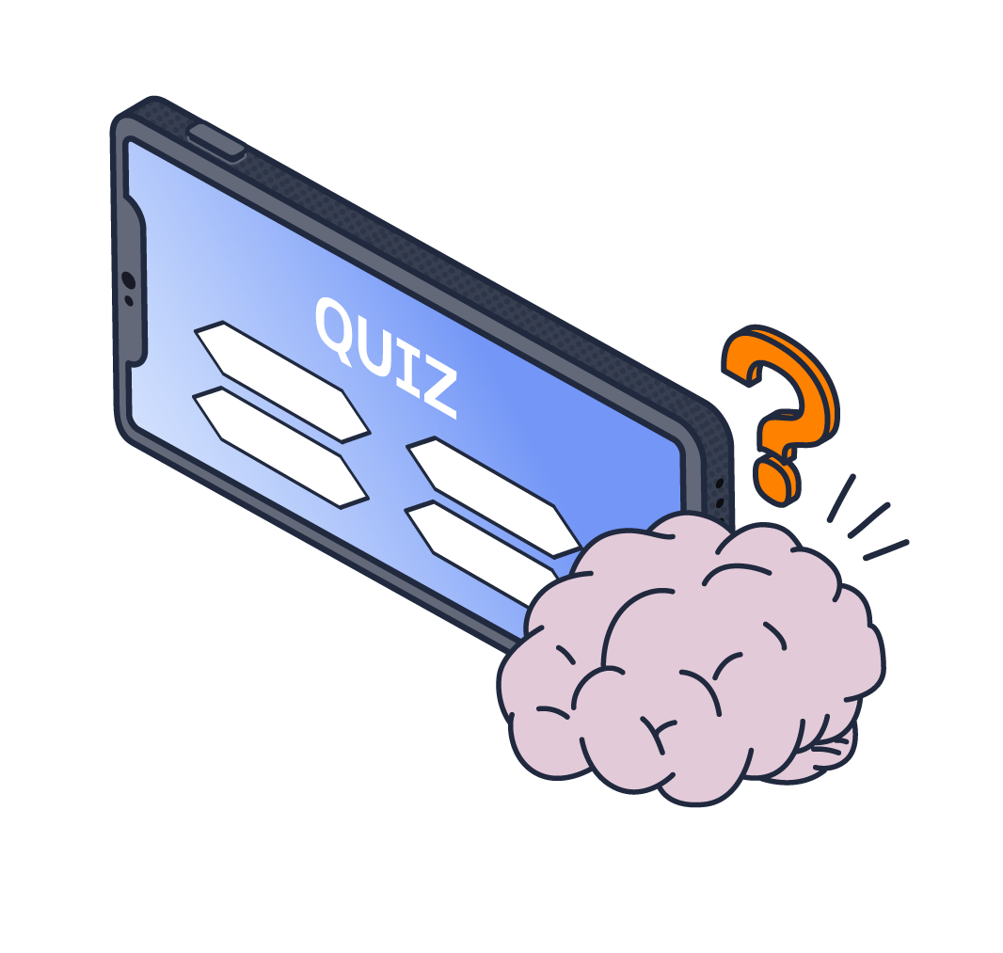KCSIE quiz

1. Have you read and understood Part One of KCSIE?

Yes

No

1. According to KCSIE, what age does a child become an adult in the UK?

13 years old

16 years old

18 years old

21 years old

1. Who is responsible for safeguarding?

DSL

Teaching staff

Support staff (e.g. TAs, catering)

All of the above

1. What are the four main types of abuse?

|  |
| --- |
|  |

1. What is the core principle of ‘early help’ as outlined in KCSIE?

Providing support to children only when a serious safeguarding concern has been confirmed

Offering help only after a child or family formally requests it

Providing support as soon as a problem emerges at any point in a child’s life

Primarily focusing on providing financial assistance to struggling families

1. Which of the following would **not** make a child vulnerable to abuse?

Witnessing or experiencing domestic abuse

Identifying as LGBTQ+

Being the tallest in the class

Having a special educational need or disability (SEND)

1. What's the name of the guidance document which defines safeguarding, the different types of abuse and the responsibilities of children's services?

Children and Social Work Act 2017

The Education Act 2002

Working Together to Safeguard Children

The Children Act 2004

1. Which of the following is an example of a **low level** safeguarding concern?

An adult sharing inappropriate explicit images with a child

A parent complaining that a teacher sent their child to the head teacher for disruptive behaviour in class

A teacher consistently using sarcasm or making degrading comments towards a particular child

A member of staff having a physical fight with a parent on school premises

1. If a child discloses information about abuse to you, what should you **not** do?

Reassure them that they are being taken seriously

Promise the child that you’ll keep it a secret

Inform the DSL immediately

All of the above

1. What is the aim of an Early Help Assessment?

To learn whether there is a risk of significant harm

To identify what kind of support a child/family needs

To help determine the Child Protection Plan

To decide whether further assessments are needed

1. KCSIE categorises online safety issues into four areas of risk. Name the four areas.

|  |
| --- |
|  |

1. What is ‘hazing’?

Fun games played by students to welcome new classmates or club members

Challenging group activities that build unity, character, and respect

Activities involving harassment, abuse or humiliation used as a way of initiating a person into a group

A series of physically demanding drills used to improve performance and discipline within a sports team

1. Which of the following is **not** an example of an emerging need?

The child has persistent poor behaviour at school

The child is regularly missing days from schools

The child appears to be misusing substances

The child is a young carer

1. When should you report a concern about radicalisation and extremism?

When the student discloses information

Immediately after you have the concern

Within a fortnight

When you have gathered evidence

1. How frequently should school staff receive safeguarding and child protection updates?

As required, and at least annually

Every two years

Only upon starting employment

Only if they work directly with children

1. According to KCSIE, what is the overarching responsibility of **all**staff in a school or college regarding safeguarding?

To manage all safeguarding referrals and liaise directly with external agencies

To only report concerns if they have definite proof of abuse or neglect

To safeguard and promote the welfare of children

All of the above

**Safeguarding scenarios**

In this section of the quiz, you will be presented with a number of safeguarding scenarios that you may come across in your setting. Please explain what action you would take in the answer box provided.

1. During break time you notice a pupil, Aled, repeatedly ‘tickling’ or playfully poking another pupil, Lucy, around their waist. Lucy visibly flinches and moves away but Aled laughs and keeps trying to do it.

|  |
| --- |
|  |

1. In the classroom, you overhear a group of pupils discussing their new friend, Lennie, who they speak to during online gaming. Lennie is not a student in your setting and you do not know his age or if he even lives in the same area. It seems that your pupil, Sam, has formed a particularly close relationship with him as he refers to a gift that Lennie recently bought him.

|  |
| --- |
|  |

1. You notice that Myla has arrived at school with bruises on her arm. When you engage in conversation with her, she quickly pulls her sleeve down and mumbles something about “falling over”. She seems unusually withdrawn for the rest of the day.

|  |
| --- |
|  |

1. A pupil, Daisy, quietly confides in you that a group of pupils have been posting mean comments and embarrassing pictures of Theo on social media. Daisy tells you that this has been happening daily for the past week and she is worried as Theo has not turned up to school this morning.

|  |
| --- |
|  |

KCSIE quiz (with answers)

1. Have you read and understood Part One of KCSIE?

Yes

No

1. According to KCSIE, what age does a child become an adult in the UK?

13 years old

16 years old

18 years old

21 years old

1. Who is responsible for safeguarding?

DSL

Teaching staff

Support staff (e.g. TAs, catering)

All of the above

1. What are the four main types of abuse?

|  |
| --- |
| Physical, emotional, sexual, neglect |

1. What is the core principle of ‘early help’ as outlined in KCSIE?

Providing support to children only when a serious safeguarding concern has been confirmed

Offering help only after a child or family formally requests it

Providing support as soon as a problem emerges at any point in a child’s life

Primarily focusing on providing financial assistance to struggling families

1. Which of the following would **not** make a child vulnerable to abuse?

Witnessing or experiencing domestic abuse

Identifying as LGBTQ+

Being the tallest in the class

Having a special educational need or disability (SEND)

1. What's the name of the guidance document which defines safeguarding, the different types of abuse and the responsibilities of children's services?

Children and Social Work Act 2017

The Education Act 2002

Working Together to Safeguard Children

The Children Act 2004

1. Which of the following is an example of a **low level** safeguarding concern?

An adult sharing inappropriate explicit images with a child

A parent complaining that a teacher sent their child to the head teacher for disruptive behaviour in class

A teacher consistently using sarcasm or making degrading comments towards a particular child

A member of staff having a physical fight with a parent on school premises

1. If a child discloses information about abuse to you, what should you **not** do?

Reassure them that they are being taken seriously

Promise the child that you’ll keep it a secret

Inform the DSL immediately

All of the above

1. What is the aim of an Early Help Assessment?

To learn whether there is a risk of significant harm

To identify what kind of support a child/family needs

To help determine the Child Protection Plan

To decide whether further assessments are needed

1. KCSIE categorises online safety issues into four areas of risk. Name the four areas..

|  |
| --- |
| Content, contact, conduct, commerce |

1. What is ‘hazing’?

Fun games played by students to welcome new classmates or club members

Challenging group activities that build unity, character, and respect

Activities involving harassment, abuse or humiliation used as a way of initiating a person into a group

A series of physically demanding drills used to improve performance and discipline within a sports team

1. Which of the following is **not** an example of an emerging need?

The child has persistent poor behaviour at school

The child is regularly missing days from schools

The child appears to be misusing substances

The child is a young carer

1. When should you report a concern about radicalisation and extremism?

When the student discloses information

Immediately after you have the concern

Within a fortnight

When you have gathered evidence

1. How frequently should school staff receive safeguarding and child protection updates?

As required, and at least annually

Every two years

Only upon starting employment

Only if they work directly with children

1. According to KCSIE, what is the overarching responsibility of **all**staff in a school or college regarding safeguarding?

To manage all safeguarding referrals and liaise directly with external agencies

To only report concerns if they have definite proof of abuse or neglect

To safeguard and promote the welfare of children

All of the above

**Safeguarding scenarios**

In this section of the quiz, you will be presented with a number of safeguarding scenarios that you may come across in your setting. Please explain what action you would take in the answer box provided.

1. During break time you notice a pupil, Aled, repeatedly ‘tickling’ or playfully poking another pupil, Lucy, around their waist. Lucy visibly flinches and moves away but Aled laughs and keeps trying to do it.

|  |
| --- |
|  |

1. In the classroom, you overhear a group of pupils discussing their new friend, Lennie, who they speak to during online gaming. Lennie is not a student in your setting and you do not know his age or if he even lives in the same area. It seems that your pupil, Sam, has formed a particularly close relationship with him as he refers to a gift that Lennie recently bought him.

|  |
| --- |
|  |

1. You notice that Myla has arrived at school with bruises on her arm. When you engage in conversation with her, she quickly pulls her sleeve down and mumbles something about “falling over”. She seems unusually withdrawn for the rest of the day.

|  |
| --- |
|  |

1. A pupil, Daisy, quietly confides in you that a group of pupils have been posting mean comments and embarrassing pictures of Theo on social media. Daisy tells you that this has been happening daily for the past week and she is worried as Theo has not turned up to school this morning.

|  |
| --- |
|  |